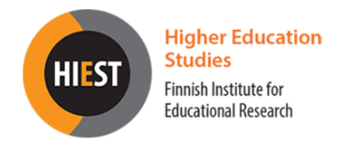

34th Annual CHER Conference
Sustainable and Responsive Higher Education
Organised online 1st to 2nd September 2022 by the
Consortium of Higher Education Researchers and the Finnish Institute for Educational Research, University of Jyväskylä

Panel submission form
Submit the panel proposal by e-mail (cher2022@jyu.fi) by 1st of May 2022

Title:

Keywords:

Panel coordinator:

Panelists:

Panelists short bios:

Abstract of the panel (500 words maximum):

Organization of time of the panel and engagement with the audience:

